Pymaceuticals Inc., a burgeoning pharmaceutical company based out of San Diego. Pymaceuticals specializes in anti-cancer pharmaceuticals. In its most recent efforts, it began screening for potential treatments for squamous cell carcinoma (SCC), a commonly occurring form of skin cancer. Two hundred forty eight mice were tested with various drug regimens. The purpose of this study was to compare the performance of Pymaceuticals' drug of interest, Capomulin, versus the other treatment regimens.

In an effort to evaluate if the drugs had an effect on tumor volume, a variety of statistical analyses were calculated. See the summary statistics table for results.

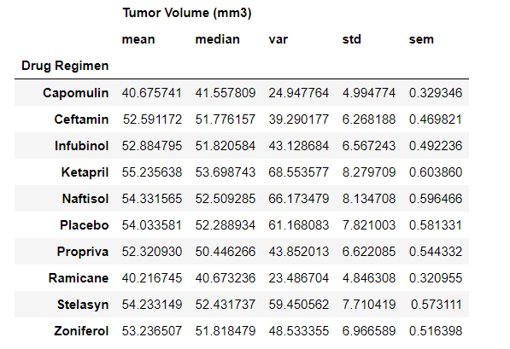

In a close review of mouse ‘g316,’ the drug Capomulin seems to have a large impact on reducing the tumor volume over time.

